Histogram to show the salary distribution among the employees

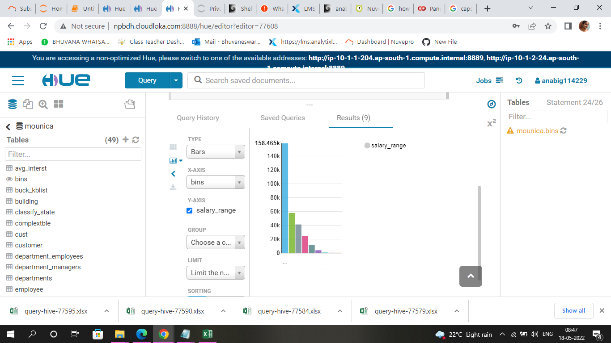

Bar graph to show the Average salary per title (designation)

